Basic Shell Scripts
Output to screen
#!/bin/bash
# Simple output script
echo "Hello World"
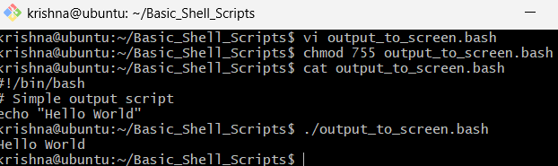
Defining Tasks
#!/bin/bash
# Define small tasks
whoami
echo
pwd
echo
hostname
echo
ls -ltr
echo
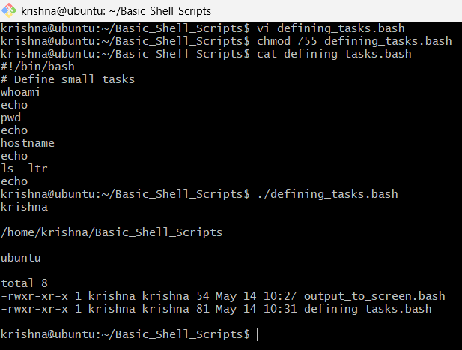
Defining Variables
#!/bin/bash
# Example of defining variables
a=Imran
b=Afzal
c=’Linux class’ # c=Linuxclass
echo "My first name is $a"
echo "My surname is $b"
echo ‘My surname is $c’
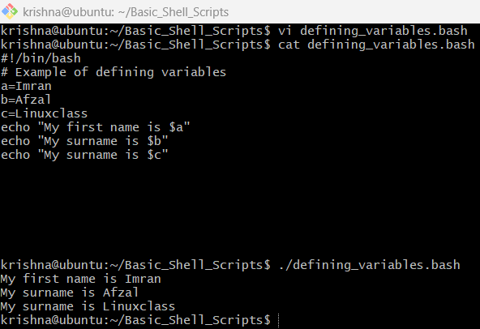
Read Input
#!/bin/bash
# Read user input
echo "What is your first name?"
read a
echo
echo "What is your last name?"
read b
echo
echo Hello $a $b
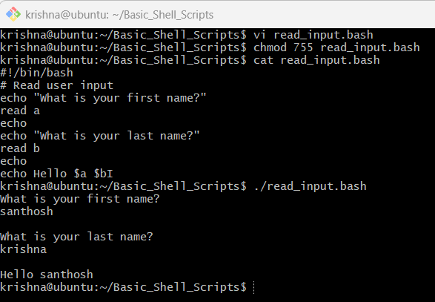
Scripts to run commands within
#!/bin/bash
# Script to run commands within
clear
echo "Hello `whoami`"
echo
echo "Today is `date`"
echo
echo "Number of user login: `who | wc -l `"
echo
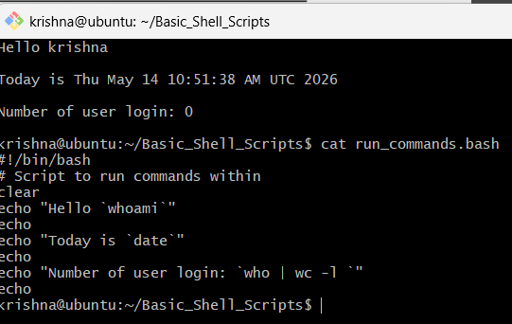
Read input and perform a task
#!/bin/bash
# This script will rename a file
echo Enter the file name to be renamed
read oldfilename
echo Enter the new file name
read newfilename
mv $oldfilename $newfilename
echo The file has been renamed as $newfilename
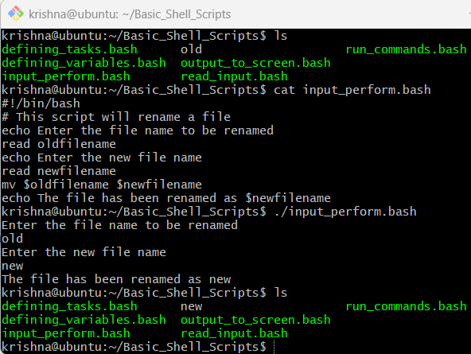
======================================================================

Case Scripts:
#!/bin/bash
echo
echo Please chose one of the options below
echo
echo 'a = Display Date and Time'
echo 'b = List file and directories'
echo 'c = List users logged in'
echo 'd = Check System uptime'
echo
read choices
case $choices in
a) date;;
b) ls;;
c) who;;
d) uptime;;
*) echo Invalid choice - Bye.
esac
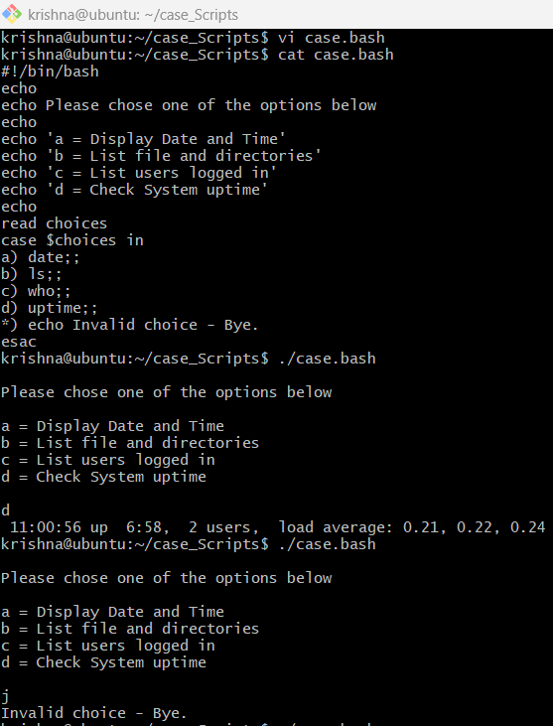
This script will look at your current day and tell you the state of the backup
#!/bin/bash
NOW=$(date +"%a")
case $NOW in
Mon)
echo "Full backup";;
Tue|Wed|Thu|Fri)
echo "Partial backup";;
Sat|Sun)
echo "No backup";;
*) ;;
esac
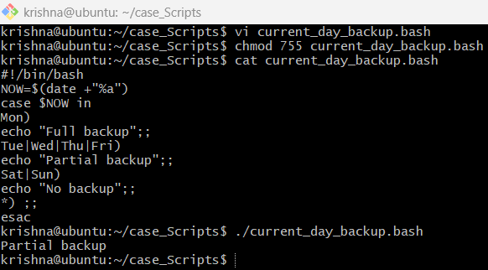
======================================================================
Do While Scripts
Script to run for a number of lines
#!/bin/bash
c=1
while [ $c -le 5 ]
do
echo "Welcone $c times"
(( c++ ))
done
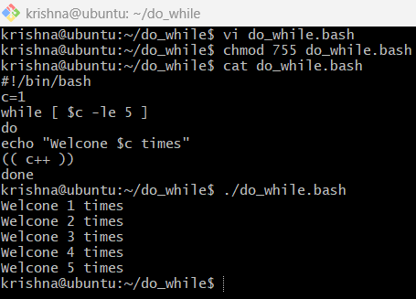
Script to run for a number of seconds
#!/bin/bash
count=0
num=10
while [ $count -lt 10 ]
do
echo
echo $num seconds left to stop this process $1
echo
sleep 1
num=`expr $num - 1`
count=`expr $count + 1`
done
echo
echo $1 process is stopped!!!
echo
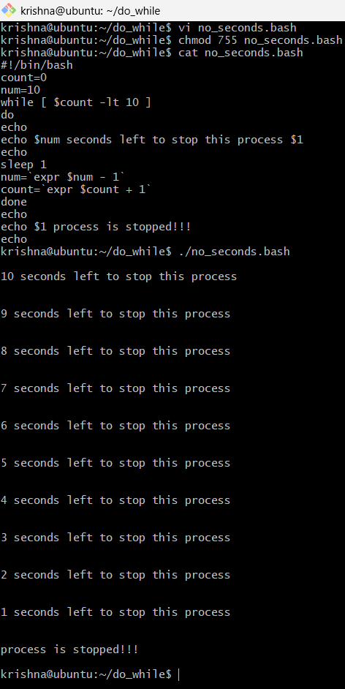

======================================================================
For loop scripts:
Simple for loop output
#!/bin/bash
for i in 1 2 3 4 5
do
echo "Welcome $i times"
done
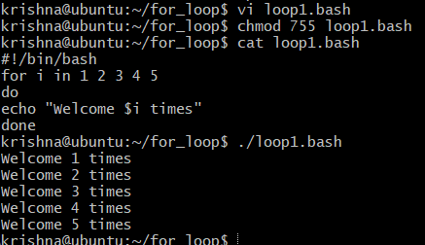
Simple for loop output2
#!/bin/bash
for i in eat run jump play
do
echo See Imran $i
done
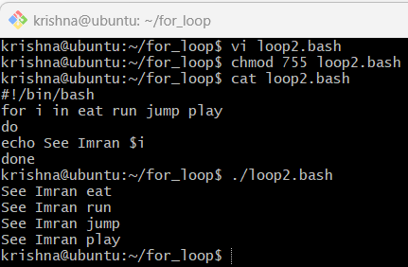
For loop to create 5 files named 1-5
#!/bin/bash
for i in {1..5}
do
touch $i
done
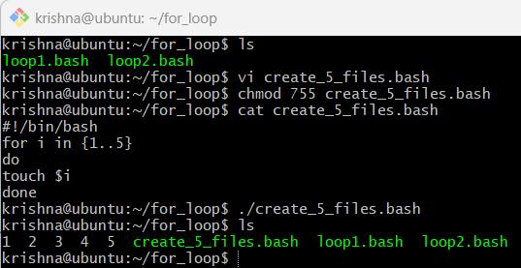
For loop to delete 5 files named 1-5
#!/bin/bash
for i in {1..5}
do
rm $i
done
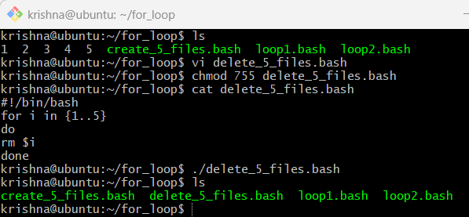
Specify days in for loop
#!/bin/bash
i=1
for day in Mon Tue Wed Thu Fri
do
echo "Weekday $((i++)) : $day"
done
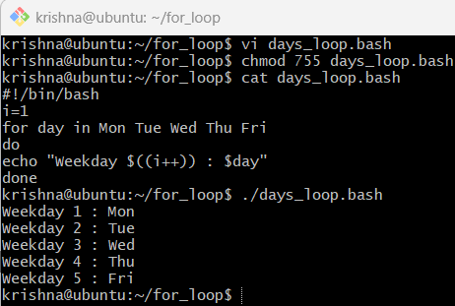
List all users one by one from /etc/passwd file
List all users one by one from /etc/passwd file
#!/bin/bash
i=1
for username in `awk -F: '{print $1}' /etc/passwd`
do
echo "Username $((i++)) : $username"
done
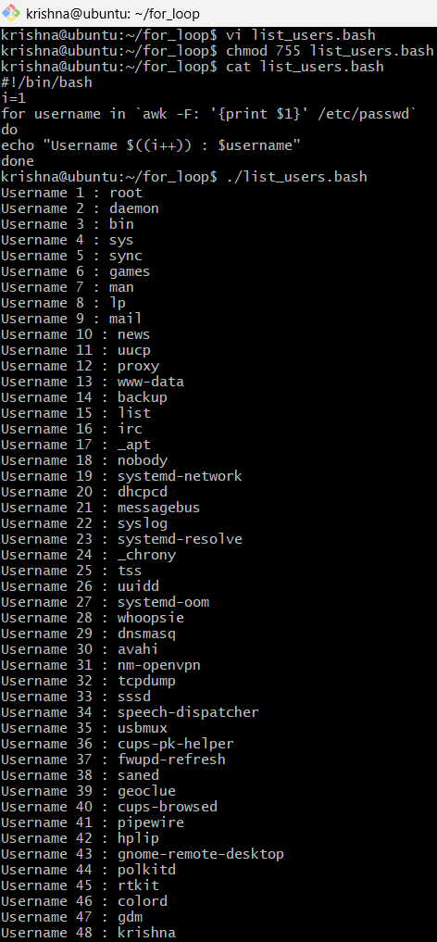
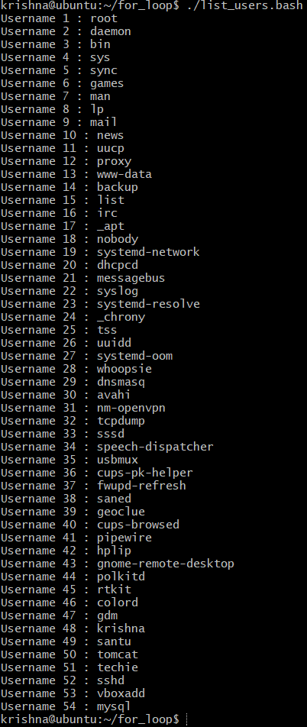

======================================================================
If-then-scripts
Check the variable
#!/bin/bash
count=100
if [ $count -eq 100 ]
then
echo Count is 100
else
echo Count is not 100
fi
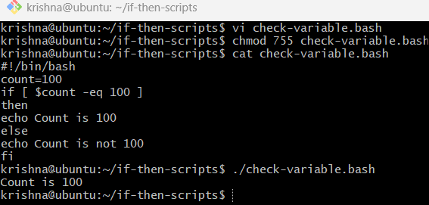
Check if a file error.txt exist
#!/bin/bash
clear
if [ -e /home/iafzal/error.txt ]
then
echo "File exist"
else
echo "File does not exist"
fi
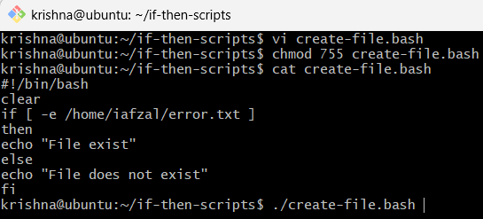
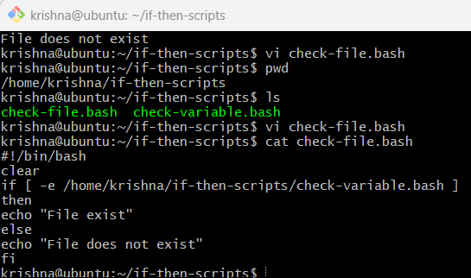
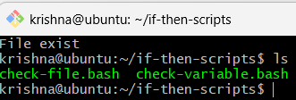
Check if a variable value is met
#!/bin/bash
a=`date | awk '{print $1}'`
if [ "$a" == Mon ]
then
echo Today is $a
else
echo Today is not Monday
fi
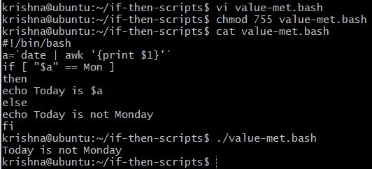
Check the response and then output
#!/bin/bash
clear
echo
echo "What is your name?"
echo
read a
echo
echo Hello $a sir
echo
echo "Do you like working in IT? (y/n)"
read Like
echo
if [ "$Like" == y ]
then
echo You are cool
elif [ "$Like" == n ]
then
echo You should try IT, it’s a good field
echo
fi
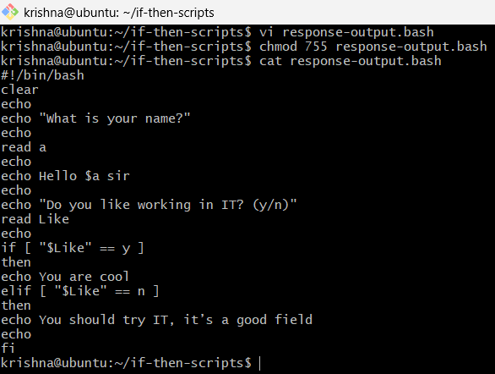
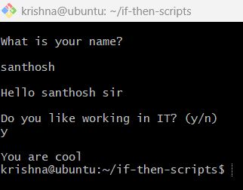

Exit Status
Return Successful Exist Status
#!/bin/bash
echo hello
echo $?
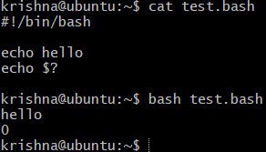
ls -l
echo $?

pwd
echo $?

pwdd
echo ?
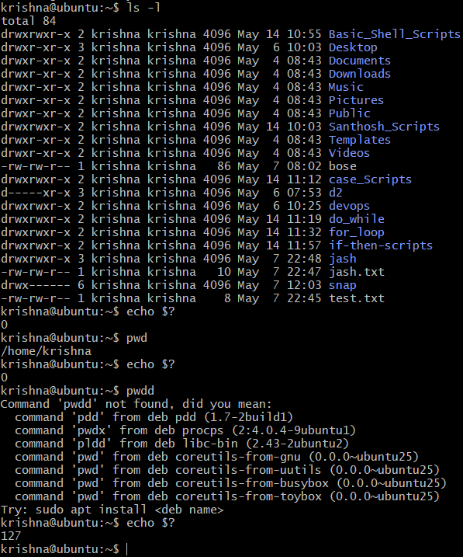

Return Un-Successful Exist Status
#!/bin/bash

echi hello
echo $?
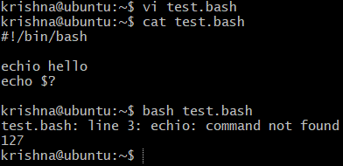
Return exist status if file exist
#!/bin/bash

ls -l /home/iafzal/check

if [ $? -eq 0 ]
then
echo File exist
else
echo File does not exist
fi
